Analysis of Virtual and Extended Realities

By Andrew Phillip Gonzalez

Industry Analysis

General description

* AR use in mobile games can be seen in games like PokemonGO, Minecraft EARTH, Jurassic Park Alive to name a few. (images needed)
  + In these games, the game world is overlayed with the world through the camera of the phone to give the impression that both realities are merged.[1]

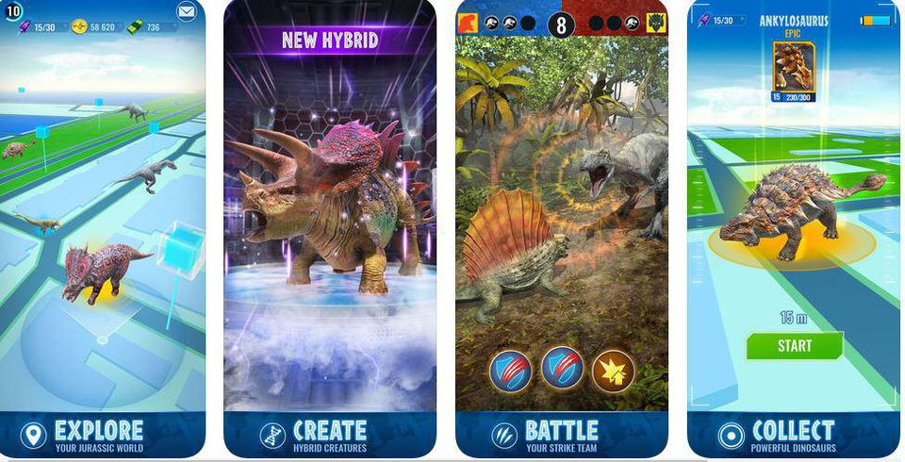

Figure - Jurassic World Alive, Mobile AR Game

* VR has had a meaningful impact in the Architectural Industry.
  + Allowing prospective clients to experience a building before it is built and see its structure, and interiors.
  + Minimizing revisions and creating a virtual environment for the client to view and give feedback, avoiding a back-and-forth situation during revisions, it can be done in situ.[2]



Figure - Virtual Reality Uses in Architecture and Design: Medium.com Article Header Image

Physiological Constraints

* Oculus
  + Interactable objects with constrained motion: Objects that exist in the virtual world in which have an effect like a lever, a switch, button etc, can suffer the limitations of accuracy, or the need for accuracy from the player, which can cause a break from immersion or a lack of consistency in behaviour of what is expected to happen.[3]
  + Therefore, a wide margin of error is required when applying an interactive design so that the player is comfortable, and immersion is not broken.

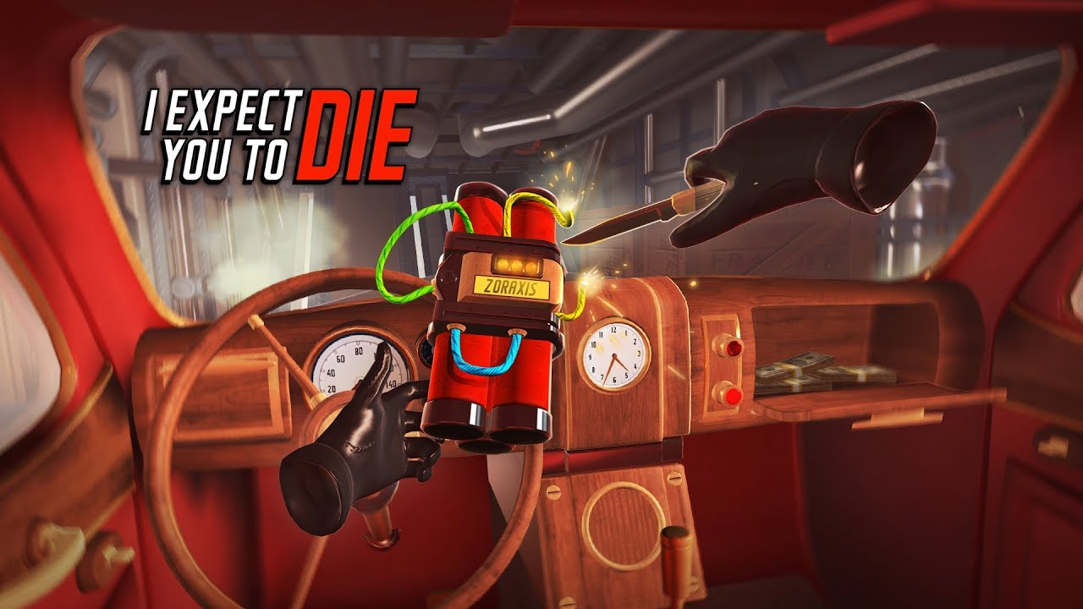

Figure - I expect you to die VR Game

HUD and UI function in Extended Realities

* Virtual Reality games
  + The design and approaches to UI and HUD is very different in design approach, having to consider the user’s sense of balance and motion.
  + Traditional UI and HUDs do not function the same way in VR, it can break the immersion of the game with a UI system that clutters the view.
  + Diegetic UI used in games like Dead Space helps from breaking immersion from the game, separating the UI from the player and making it part of the world of the character instead, the player sees what the character sees.
  + Another advantage in their approach to the Dead Space UI was that when the inventory was pulled up, it did not pause the game, so players had to carefully decided where to take stock of their items.

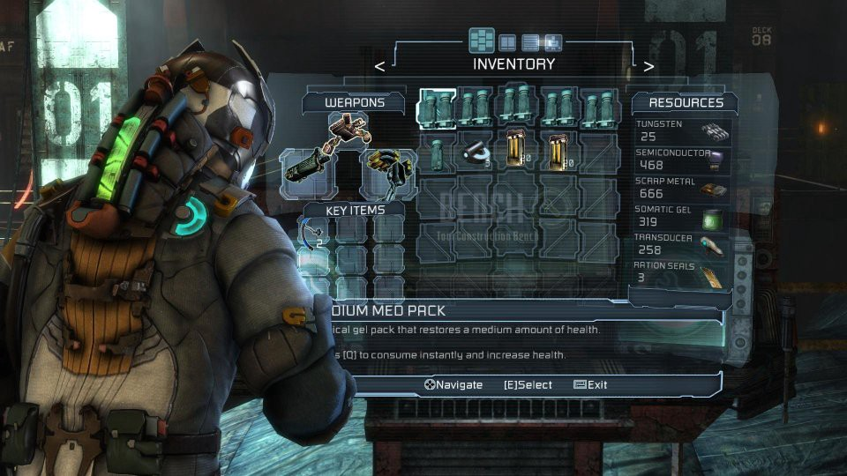

Figure - Dead Space 3 Diegetic UI

* + Doom 2016 in VR uses a detached UI that rotates with the players head, emulating the fact the player is using a helmet as Doom Guy.[4]

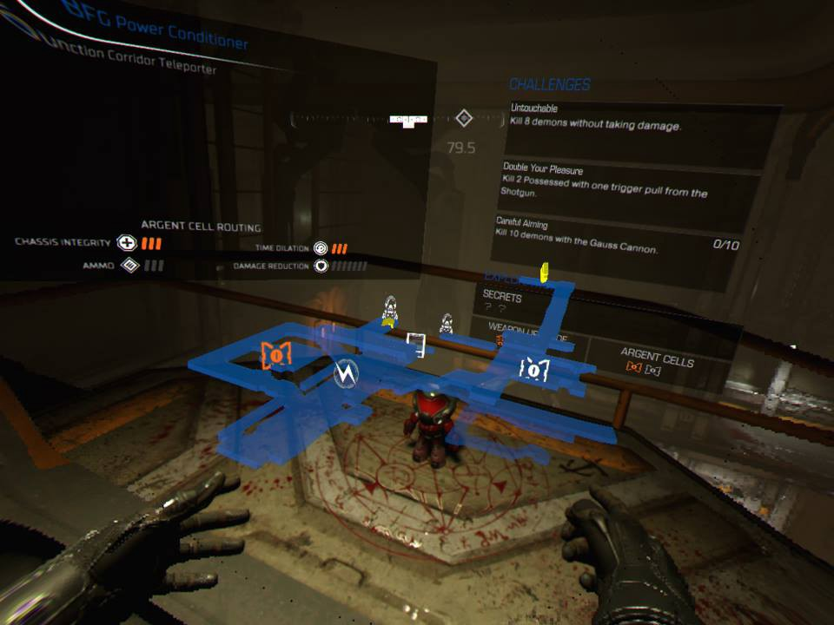

Figure - Doom VFR UI

Use of Haptic feedback in Extended Realities.

* The use of haptic feedback in surgery is a great advantage in the advancements of medicine, especially in surgery training.
  + Haptic feedback allows the surgeon to ‘feel’ resistance when it comes to cutting with a scalpel.
  + Simulations go beyond the sense of novelty and can feel like an actual learning experience.
  + There is minimal risk to patient and doctors.[5]

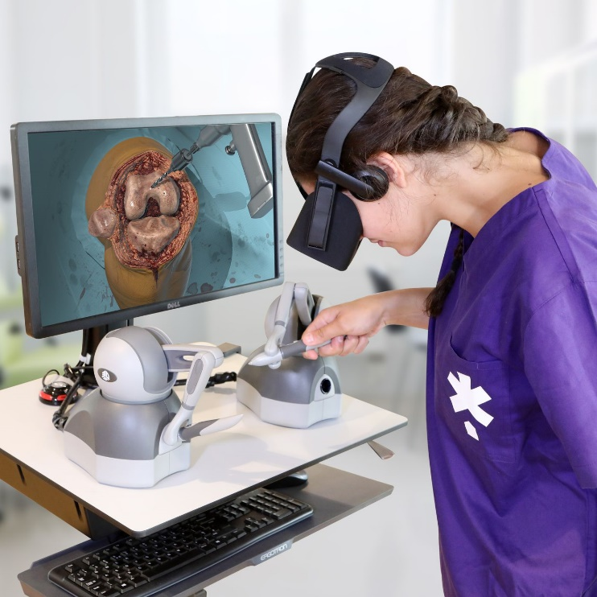

Figure - Knee Surgery VR

1. https://en.wikipedia.org/wiki/Augmented_reality#Reality_modifications
2. https://medium.com/studiotmd/virtual-reality-uses-in-architecture-and-design-c5d54b7c1e89
3. https://developer.oculus.com/blog/-object-interaction-part-4-constrained-interactions/
4. https://uxdesign.cc/vr-diegetic-interfaces-dont-break-the-experience-554f210b6e46
5. https://www.theverge.com/2018/8/14/17670304/virtual-reality-surgery-training-haptic-feedback-fundamentalvr